20120011658 김진권

<UART>

1.

vh_ULCON1 = 0x3;vh_UCON1 = 0x245;vh_UFCON1 = 0xc7;vh_UINTM1 = 0xe;vh_UINTP1 = 0xf;

2.

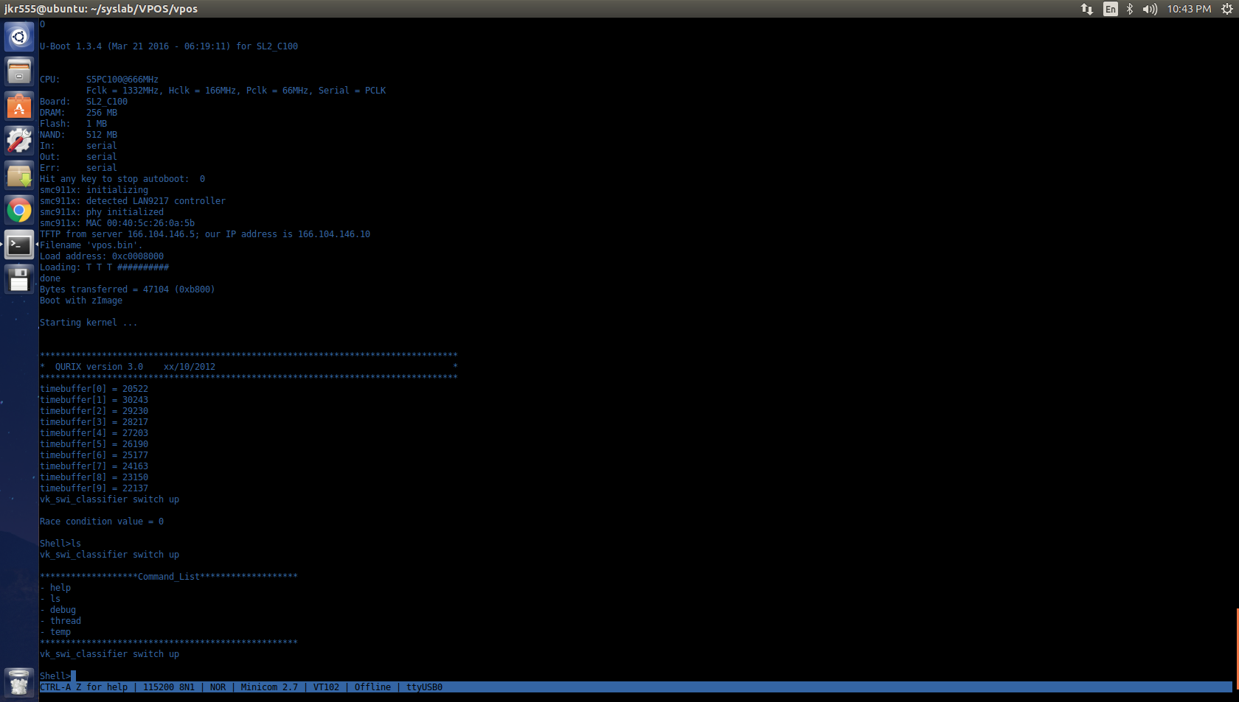

<timer>

1.

void vh_timer_init(void)

{

//Timer4 Configuration

vh_TCFG0 = vh_vTimer_CFG0;

vh_TCFG1 = vh_vTimer_CFG1;

vh_TCNTB4 = vh_vTimer_TCNTB4;

vk_timer_flag = 0;

}

// Reserved [31:24] Dead Zone length [23:16]

// Prescalar1 [15:8] Prescalar0 [7:0]

// Prescalar1 = 132 -> 66,000,000 Hz -> 500,000 Hz

#define vh_vTimer_CFG0 0x8300

// Reserved [31:24] Divider MUX4 [19:16]

// Divider MUX3 [15:13] Divider MUX2 [11:8]

// Divider MUX1 [7:4] Divider MUX0 [3:0]

// Divider = 16 -> 500,000 Hz -> 31,250 Hz

#define vh_vTimer_CFG1 0x4000

// TCNTB4 = 31,250

#define vh_vTimer_TCNTB4 0x7A12

1초에 1번 timer가 발생해야 하므로

presclar & devider 값을 각각 131(132) ,16으로 하여 66,000,000/132/16 = 31,250 Hz하고 TCNTB4 값을 31,250으로 설정한다.

2.

// Pulse Width Modulation Timer bae address

#define vh_PWM_BASE 0xEA000000

// Specifies Timer Configuration Register0

#define vh_TCFG0 (*(volatile unsigned*)(vh_PWM_BASE+0x00))

// Specifies Timer Configuration Register1

#define vh_TCFG1 (*(volatile unsigned*)(vh_PWM_BASE+0x04))

// Specifies Timer Control Register

#define vh_TCON (*(volatile unsigned*)(vh_PWM_BASE+0x08))

// Specifies Timer Interrupt Control and Status Register

#define vh_TINT_CSTAT (*(volatile unsigned*)(vh_PWM_BASE+0x44))

// Specifies Timer 4 Count Buffer Register

#define vh_TCNTB4 (*(volatile unsigned*)(vh_PWM_BASE+0x3C))

// Specifies Timer 4 Count Observation Register

#define vh_TCNTO4 (*(volatile unsigned*)(vh_PWM_BASE+0x40))

3.

